bij de bakker

|  |  |  |
| --- | --- | --- |
|  |  |  |
|  |  |  |
|  |  |  |
|  |  |  |
|  |  |  |
|  |  |  |
|  |  |  |
|  |  |  |
|  |  |  |
|  |  |  |

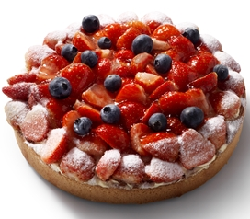[](https://www.google.nl/url?sa=i&rct=j&q=&esrc=s&frm=1&source=images&cd=&cad=rja&uact=8&ved=0CAcQjRxqFQoTCNea28DWo8gCFQVSFAodKf8BQA&url=https://bridor.com/en/products/viennese-pastry/croissant-en/croissant-beurre-alveole-pac-59101-ca/&psig=AFQjCNHL7vr33j994JCZjQkoDOZzqNLzXw&ust=1443871461451419)[](http://www.google.nl/url?sa=i&rct=j&q=&esrc=s&frm=1&source=images&cd=&cad=rja&uact=8&ved=0CAcQjRxqFQoTCJXU_tTWo8gCFYJYFAodp9oFPQ&url=http://koekiemonstersrotterdam.nl/product/pinda-krakelingen/&bvm=bv.104317490,d.d24&psig=AFQjCNH6jeYPq_CVVBih-PsAo_m4Ap45uA&ust=1443871501639914)